21BDS0340

Abhinav Dinesh Srivatsa

Technical Report Writing

Assignment – V

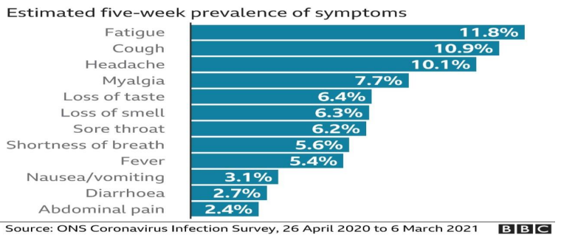

**Q. What does the graph exactly show?**

A. The graph shows the persistence of symptoms that stay with a group of individuals who were infected by Covid-19 for the first five weeks. From the graph, we can see that the most prevalent symptom is fatigue, affecting 1 in 8 people approximately. The least prevalent symptom is abdominal pain, affecting 1 in 42 people approximately.

**Q. Which two symptoms are the most common in Covid-19 patients?**

A. The most common symptom among the Covid-19 patients is fatigue, affecting 11.8% or 1 in 8 people and cough, affecting 10.9% or 1 in 9 people.

**Q. Mention some home care remedies if confirmed with Covid-19.**

A. A few home care remedies for someone who is confirmed to have Covid-19 is to isolate themselves, wear a triple layered mask to prevent the spread to others and treat it like they have a fever, lots of rest, fluids to drink and frequent temperature checks.

**Second question on the next page.**

**Q. Which sports are relatively popular among students?**

A. The three equally most popular sports are football, basketball and badminton.

**Q. What kind of information does the pie chart offer?**

A. The pie chart offers the information of the popularity of sports by percentage for a certain college’s students.

**Q. Which two sports are unfamiliar in your opinion and why?**

A. The two unfamiliar sports are hockey and cricket, each with a respective 12.5% popularity rating, while the other 3 sports football, basketball and badminton each have a 25% popularity.